**4 - R710 Adding TWO 1TB discs in RAID 1**

**Drive installation:**

1. Fit the new discs in the caddies and insert into R710
2. With Monitor and Keyboard fitted, turn R710 ON
3. Wait for BIOS to finish BOOT init’ and checks.
4. When prompted, press CTRL-**R** to enter RAID Setup.
5. Use cursor ip/down to highlight Controller 0  
   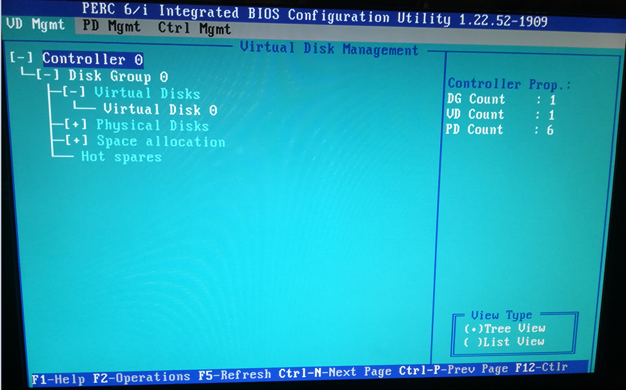
6. Press **F2**, select “Create New VD” and press Enter  
   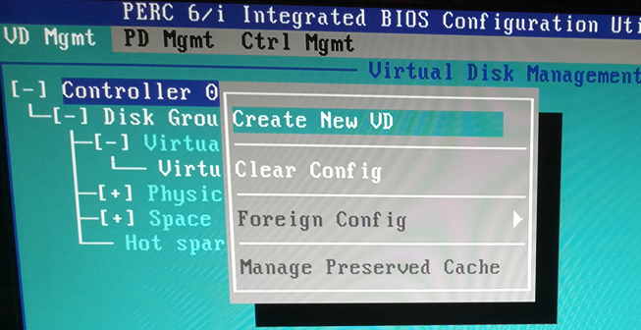
7. Adjust RAID level to RAID-1  
   (before):  
   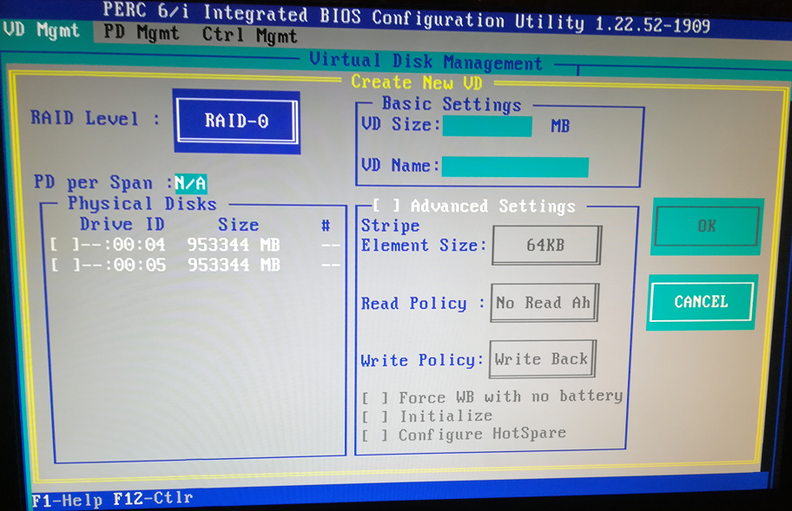  
   (after):  
   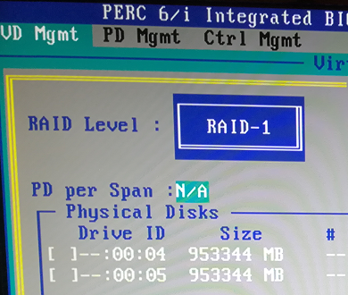
8. Scroll down and select physical discs with SPACE key.  
   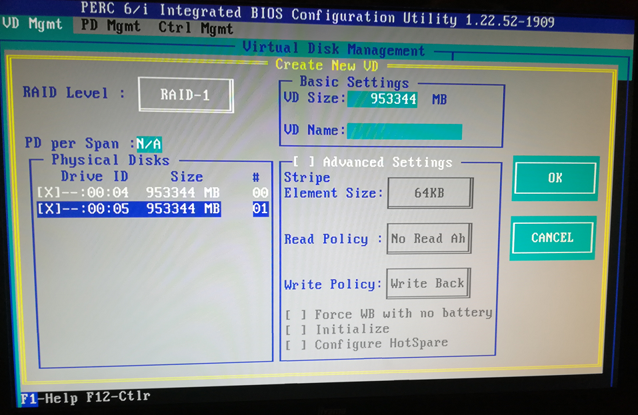
9. TAB to “VD Name” and enter “v1”  
   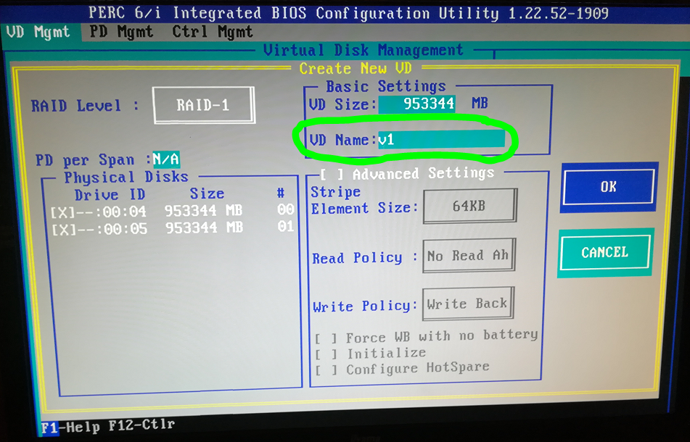
10. TAB to OK and press Enter
11. A prompt pops up to say init’ new drives, press Enter  
    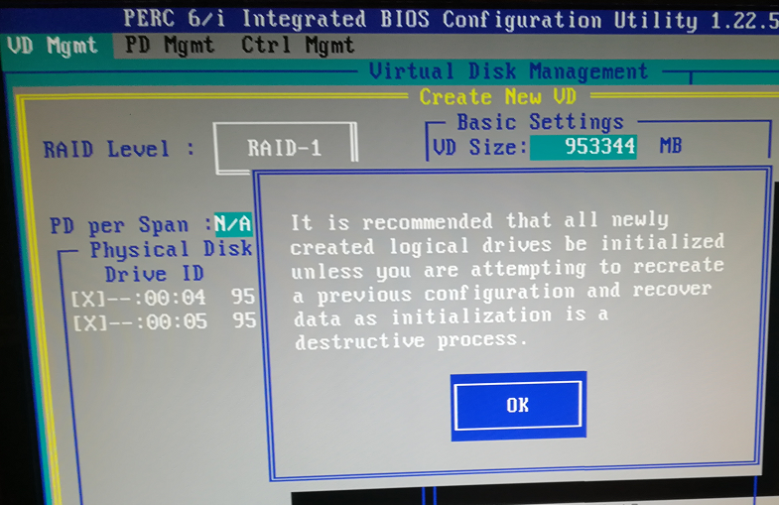
12. Scroll down to Virtual Disk 1 and press F2.  
    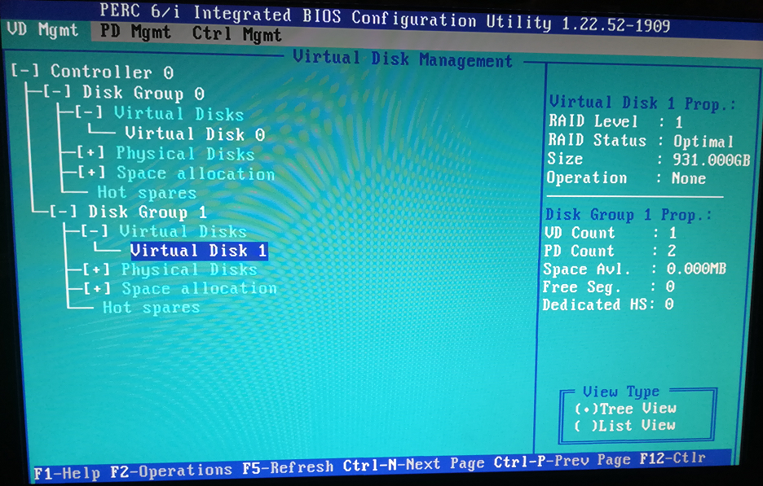
13. Press Cursor right to see “Start Init”. Press Enter  
    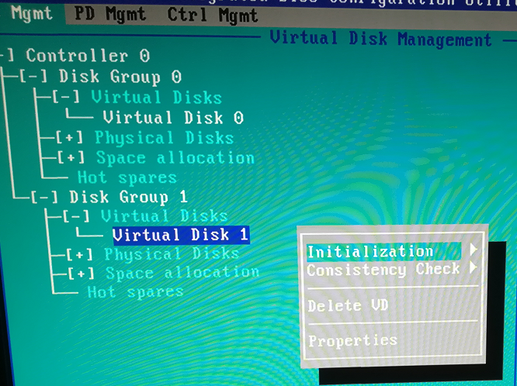
14. Select “YES”:  
    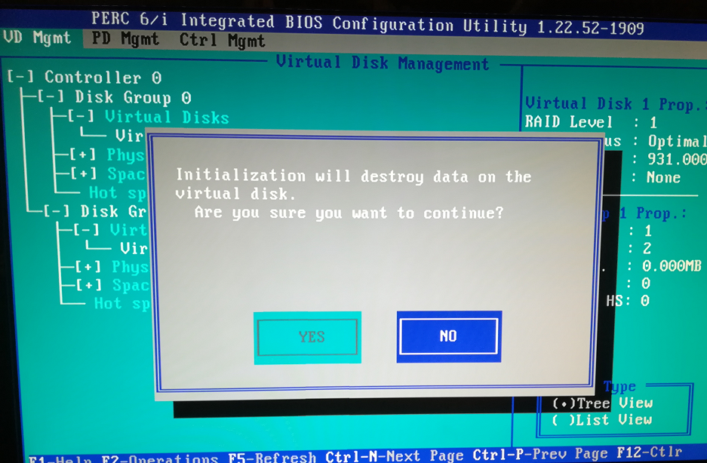
15. After some time the init looks like:  
    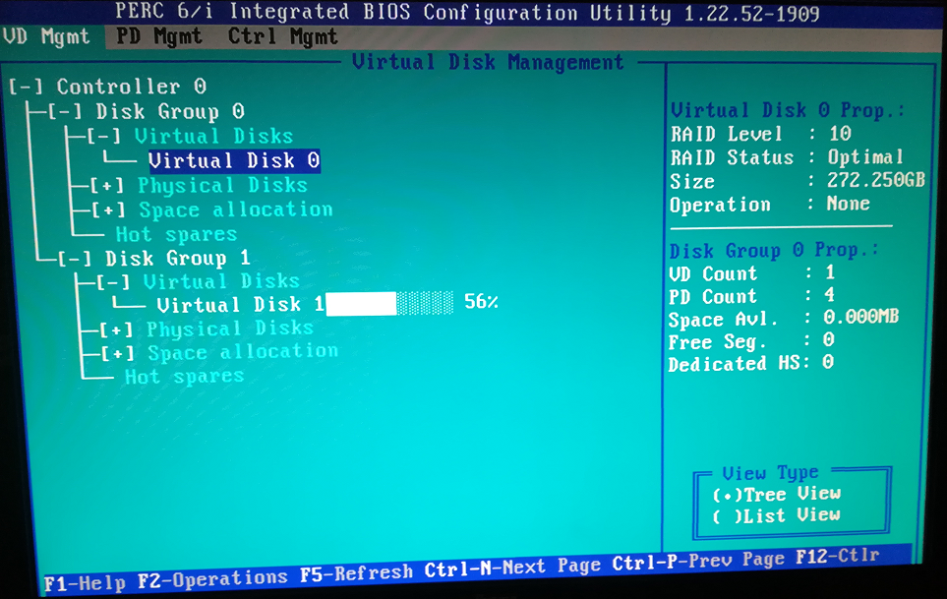
16. After approx. 2 hours the new discs will complete initialisation:  
    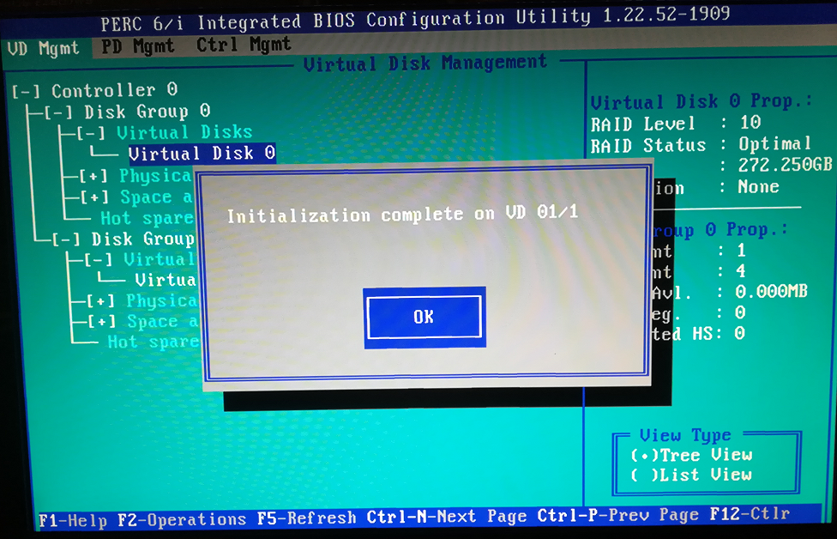
17. Press Enter to Reboot. And press CTRL-ALT-DEL as instructed.

**Volume creation in Proxmox:**

From this video:

<https://www.youtube.com/watch?v=wzBz4GYqw-Y>

Steps to add new local storage to your Promox VE:

1. Login to the web interface of your Proxmox VE

2. Once login, select the node where the hard drive is installed

3. Click on Shell to open shell environment

4. Find the drive to add, and do this by tying **fdisk -l**. This would list all the drives currently installed.

In my case, I have 2 drives installed and are labelled sda and sdb.  
**sdb** is the new drive to be added

5. Once drive found to be added, type the command

cfdisk and the drive identifier, in this case, the command is:

**cfdisk /dev/sdb**

Select label type to be: dos for disk less than 1TB

BUT for disk > 1TB (and also NVME SSd’s), I selected gpt

6. If you have an old partition on the hard drive and you want to remove them, just select delete, otherwise if it is a new HDD, it would not have a partition installed, next you select:

**New** -- The size you want the new partition to be – use all of the 931GB offered.

I selected **primary**, and it set up /dev/sdb1 as Id 83, Type Linux

Then select **Write** (before **quit**)

partition type (primary or extended), once you are done, select Quit.

7. Next, we create a physical volume, by typing:

**pvcreate /dev/sdb1**

(for NVME, after selecting gpt above on prox3, when prompted, I selected yes … hmmm)

8. Next, you create a volume group with:

vgcreate "volume group name" device name, we chose Data1 and our volume name in our example drive, the command would be

**vgcreate Data1 /dev/sdb1**

**Making new Volume LVM-Thin:**

As I’m going to be creating LVM-Thin, extra steps are needed:

From video:

<https://www.youtube.com/watch?time_continue=5&v=isV9QeM53J8&feature=emb_logo>

**lvcreate –L 930G –n g1-data Data1** (930 is the max size of the disc that works)

(or for 2TB disk: lvcreate -L 1860G --name g1-data Data1)

**lvconvert --type thin-pool Data1/g1-data**

(or for 2TB disk: lvconvert --type thin-pool Data1/g1-data –Zn)

9. The last thing to complete the process is to add the new storage to Promox, and we do that by:

a. Click on the **Datacenter**

b. Click on **Storage**

c. Click ‘**Add**’ and select LVM-Thin

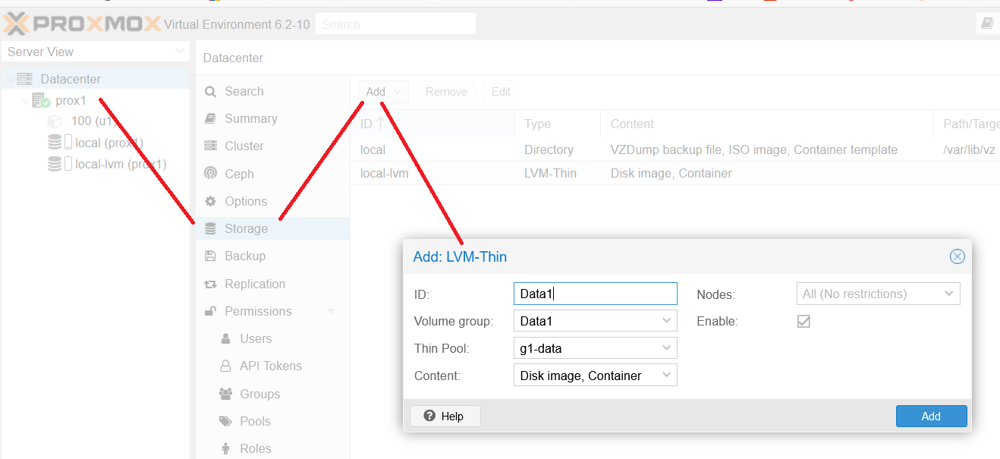

d. Enter an ID for the storage you want to add, and select ‘**Thin Pool**’, etc (as above)  
 Click on ‘**Summary**’ to see that the ‘**Storage**’ has increased to **1.15TB**:  
 (or 2.05TB for 2TB disks)  
  
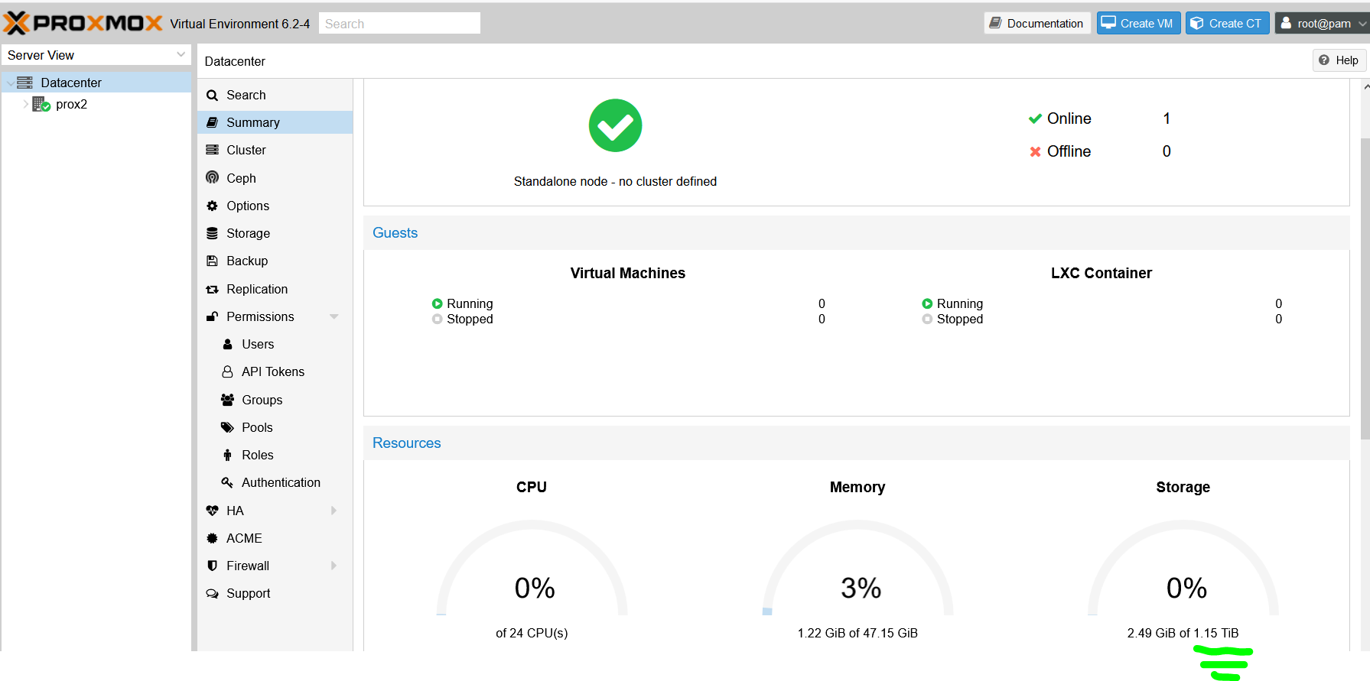

**The following steps are for just ‘LVM’:**

e. Make sure "Existing Volume group" is selected under base storage

f. Select the volume group created previously (in this case it is Data1)

g. Hit Add and we are done